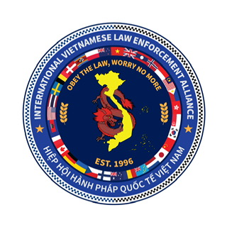
IVLEA TOUR & CONFERENCE REGISTRATION 2026
SURNAME:
FIRST NAME:
DOB:
ADDRESS:
P/CODE:
PHONE: (W) (M)
PASSPORT NO: COUNTRY OF ISSUE: EXPIRY:
EMAIL:
SERVING POLICE: YES/NO
RANK/POSITION:
COUNTRY/STATION/SQUAD/PAC/PD:
YEAR OF SERVICE:
EMERGENCY CONTACT:
RELATIONSHIP: PHONE:
SPECIAL MEALS: YES/ NO
T SHIRT SIZE: S M L XL XXL XXXL

PLEASE COMPLETE ONE FORM PER PARTICIPANT
30th Anniversary Conference (ONLY) Payment
This fee only applies if you wish to attend the conference, independently of the tour. If you are participating in the tour it is included in the tour payment, skip to the next section titled “30th Anniversary Tour/Travel Payment.” A fee of $250 AUD per person is required at the time of registration. This must be done electronically to the following bank account:
Bank: Police Credit Union
Name: Luc NGUYEN
BSB number: 815 000 Account number: 10045547735192 (Please reference ‘Conference’ and your name). Police Bank customers only (Acc No. 35192)
Event Registration fee covers the following:
- Transportation from Cam Ranh International Airport to your accommodation, as well as to and from the conference.
- 30th Anniversary activities on 25 and 26 April 2025
- Venue hire
- Translator services
- Light refreshments and lunch will be provided for both days of conference
- Official gifts
- Professional Photographer (Individual/Groups)
30th Anniversary Tour/Travel Payment (includes conference)
Estimated total $4100 AUD for full tour. A deposit of $500 AUD per person is required at the time of registration on 26/12/2025. This must be done electronically to the following bank account:
Bank: Police Credit Union
Name: Luc NGUYEN
BSB number: 815 000
Account number: 10045547735192 (Please reference ‘Study Tour’ and your name). Police Bank customers only (Acc No. 35192)

Tour Registration fee covers the following:
- International/Domestic Air tickets.
- Transportation from International/Domestic Airports (within Vietnam) to your accommodation, as well as to and from the conference.
- Accommodation
- Travel Insurance
- Vietnam/Cambodia Visas
- Official gifts
- IVLEA merchandise (Team Polo-T-shirt, Baseball Cap, Tie, Scarf, Mug, challenge coins)
- Attendance at the 30th Anniversary Conference

SOCCER: YES / NO GOLF: YES / NO Handicap: SUPPORT CREW: YES / NO

By completion of this registration form, all Study Tour & Conference Participants acknowledge that they are guests of international Police jurisdictions and are bound by the laws of that country. Police Study Tour and Conference participants are expected to always conduct themselves with the highest standards of professional and respectful behaviour, and not bring themselves, the IVLEA, or their home policing jurisdiction into disrepute.
NOTE:
Unless funded by your policing agency. All conference participants will be attending in their own time and self-funded, with the knowledge of their respective Police Services/ Forces.

